List of panelists for Safe Space event on 19th November 2021:
Role in the panel | Bionote | Picture
Dr. B. P. Sanjay Chairperson | Prof. B.P Sanjay has nearly four decades of experience in teaching and research in media and communication studies. He also has a vast experience in educational administration in both state and central universities in India. Added to this, he was also heading an institution of national importance, the Indian Institute of Mass Communication during his career.  Sanjay was involved in studying the historic Satellite Instructional Television Experiment (SITE) and his professional expertise and interests are in the areas of political economy of information and communication technologies, development communication, and international communication. He has been associated with various national and international bodies that chalk out policies on media education and research.  E mail: bpssn54@gmail.com | 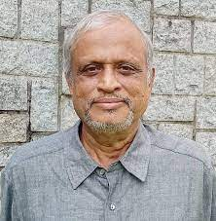
Mohammad Sahid Ullah,  Co-Lead  SARRH  JETREG | Mohammad Sahid Ullah is a Professor at the Department of Communication and Journalism, University of Chittagong, Bangladesh. He holds a Ph.D.from the University of Queensland in Communication and Arts. He has a high-status achievements tract and multiple award winners on the international stage of research and intellectual contributions. He is the author of two books with international reputes, 50 plus book chapters, and research articles published in impact factors journals including International Communication Gazette, Journal of Science Communication, Journalism Studies, South Asia Research, Asia Pacific Media Educators and many more. He served as the Co and Vice-Chairs of the Law Section of the International Association for Media and Communication Research (IAMCR) for a decade (2006-2015).  E mail: ullah_sahid@yahoo.co.uk | 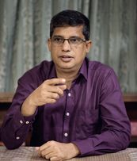
Mamunor Rashid;  Bangladesh Lead;  SARRH JETREG | Mamunor Rashid is working as an academician, researcher, media practitioner, columnist and freelance journalist and also coordinator of Disaster Perception, a voluntary organization. Mr. Rashid is presently working as an Assistant Professor in Mass Communication and Journalism in Khulna University and also worked as Head In-Charge (Temporary) from October 2020 to June 2021 at the same discipline.  E mail: mrashid@mcj.ku.ac.bd | 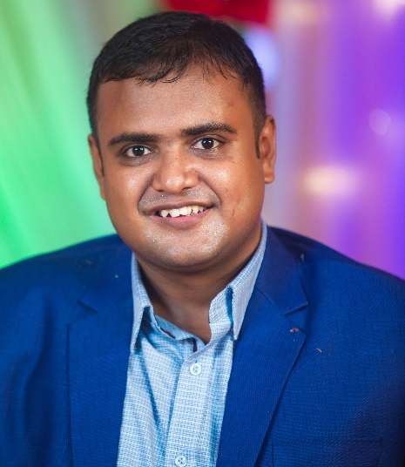
Khawaza Main Uddin  Invited Panelist from Bangladesh | Khawaza Main Uddin has been pursuing journalism in Dhaka for 27 years. He is the only Bangladesh journalist to win the UN MDG Award-2007 and the first Bangladeshi to win Developing Asia Journalism Award in 2008. He is a winner of WFP award twice. He is one of a few Asian journalists who have been interviewed in a book titled “Bridging the Cultural Gaps in Journalism Training and Education in Asia”. He wrote a weekly column titled ‘Life in the delta’ focusing on socio-political, economic development and cultural issues in 2010-2012, wrote Op-ed pieces in daily newspapers in 2014, and ran another column titled ‘NEWSLINE’ between 2015 and 2019.  E mail: khawaza@gmail.com | 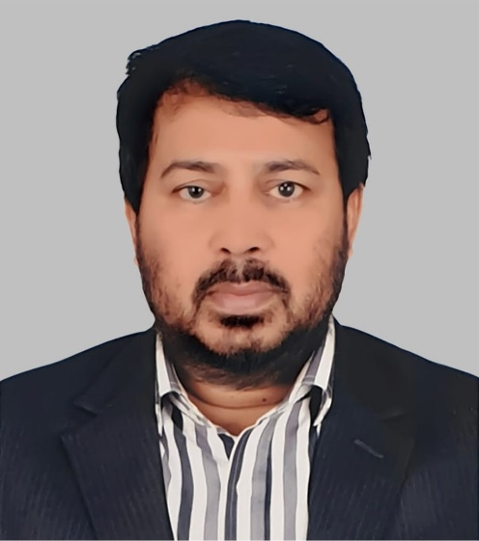
Shah Sajeda  Invited panelist from Bangladesh | Shah Sajeda is the editor of the Dainik Shahnama Patrika, a Bengali vernacular published from divisional town of Barisal, Bangladesh. An educationist, journalist, woman leader and social worker Shah Sajeda involved with journalism and publication for about four decades. She has contributed numerous articles and columns in newspapers and magazines including the weekly Bichitriya and Chitra Bangla and the weekly Khabar. She continues to work for women's rights by keeping herself engaged against gender inequality.  E mail: sajedashah1971@gmail.com | 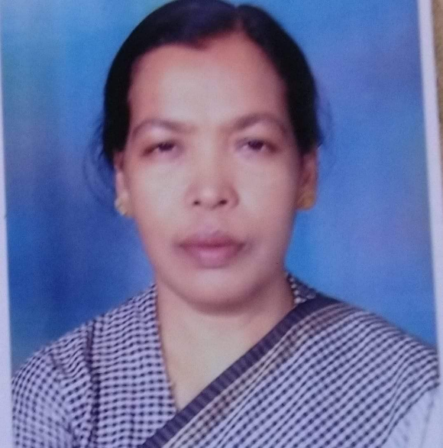
Dr. Sajjad Ali Pakistan Lead | Dr.sajjad ali is assistant professor at the department of journalism and mass communication, University of Malakand, Khyber Pakhtunkhwa, Pakistan. His research interests include media & digital Literacy, Peace & conflict journalism and multidisciplinary research.  E mail: sajjadjmc@uom.edu.pk | 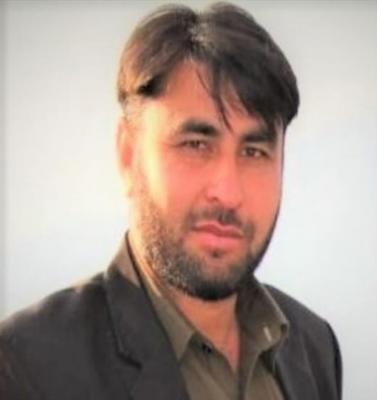
Muhammad Shahid  Pakistan co- Lead  SARRH  JETREG | Muhammad Shahid is a journalist based in Peshawar. He is also doing PhD in Journalism and Mass Communication from the University of Peshawar and researching newsroom convergence and the newspaper industry’s transformation in the digital age. He has worked for The News, Arab News, a Saudi newspaper, Daily Times, The Nation, The Frontier Post, and The Statesman. Besides, he has also served various international organizations such as GIZ, UNHCR, etc. in media-related roles. He has won the Excellence Award in Journalism in 2016 from CEJ-IBA, Karachi in the best correspondent category across Pakistan.  E mail: shahid152001@yahoo.com | 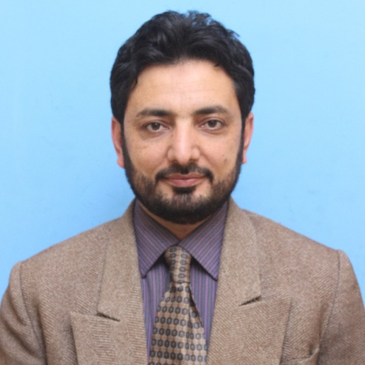
Dr Achala Abeykoon  Sri Lanka Lead  SARRH  JETREG | Dr. Achala Abeykoon serves as a Senior Lecturer at the Department of Mass Communication, University of Kelaniya, Sri Lanka. She received her Ph.D. in Communication Studies from Deakin University, Australia, completed her M.Sc. Degree in Development Communication and Extension at the University of Peradeniya, Sri Lanka and graduated with a Bachelors Honours Degree from the Eastern University, Sri Lanka. Her research interests are on communication technologies and development, journalism, gender and media, culture and communication and new media and communication.  E mail: achalas@kln.ac.lk | 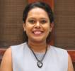
Ms. Gagani Weerakoon  Invited panelist from Sri Lanka | Ms. Gagani Weerakoon is working as the Deputy Editor for Ceylon Today Newspaper. She has an 18-year experience as journalist covering news and features for leading daily and weekly newspapers and radio stations. She is recipient of several awards such as; Presidential Award for Best Column (English) 2018; Sri Lankan winner of South Asian Inquirer Award by Thomson Foundation in 2013 (Print Media category); Mervyn de Silva Best Journalist of the Year in 2010 with a honourable mention awarded by the Editor’s Guild of Sri Lanka; D.R. Wijewardene Award (merit) for the best feature writer of the year in 2010.  E mail: gvidwa@gmail.com | 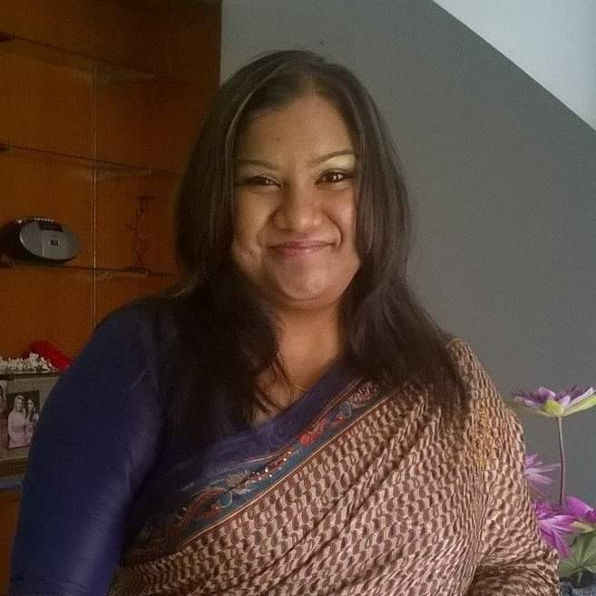
Dr. Chiranjibi Khanal  Nepal Lead  SARRH  JETREG | Chiranjibi Khanal is a Professor of Journalism and Mass Communication in Tribhuvan University, Nepal. The Head of Central Department of Journalism and Mass Communication, Professor Khanal is a media educator with more than 32 years of experience in conducting media training, research, and publications. He has interest to organize media programs primarily focus on basic and specialized areas of Ethnic Minorities and Marginalized Communities in remote parts in Nepal.  E mail: khanalnp@gmail.com | 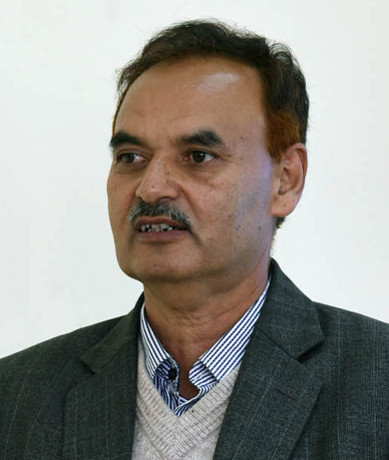
Ms. Nitu pandit  Invited panelist from Nepal | Ms Nitu Pandit has more than 20 years of professional experience in Media. Currently, she is President of Sancharika Samuha Nepal, General member of Federation of Nepalese Journalists and Economic Journalists Association. She has worked from grassroots to the national level advocacy, research and public outreach and community media mobilization programs for gender equality and women's empowerment. Relentlessly working to strengthen the capacity of working journalists and to advocate their rights. Also honored by Supraval Janasewa Shree Award 2076 and Kriyasil Patrakarita Puraskar 2076 from Press Council Nepal from Rt. Honorable President of Nepal.  E mail: panditnitum@gmail.com | 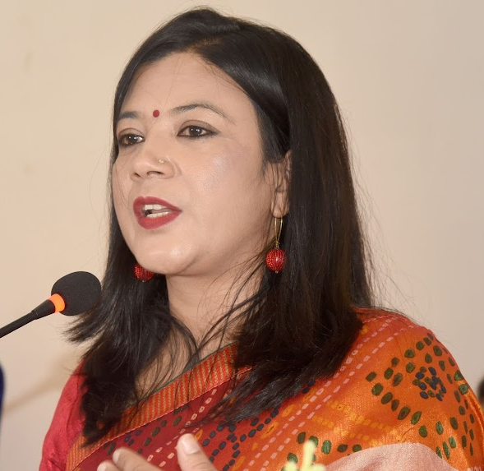
Mr. Guna Raj Luitel  Invited panelist from Nepal | Guna Raj Luitel is the Editor-in-Chief of Nagarik, Nepal's leading national daily. Previously, he led Annapurna Post, another major daily newspaper in Nepal. Luitel was principal writer/commentator of Nepal's most read online portal setopati.com. He was also a columnist of Nepali Times, Kathmandu-based English weekly. Luitel worked as a news editor at Kantipur national daily. He has been active in Nepal's mainstream journalism for almost three decades. Luitel holds an MA in journalism from the Asian centre for Journalism at Atenoe de Manila University, Philippines and MA in sociology from Tribhuvan University.  E mail: gunaraj@gmail.com | 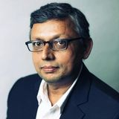
Dr. Pallavi Majumdar Bhutan Lead  SARRH  JETREG | Dr Pallavi Majumdar is Professor (Mass Communication) at Royal Thimphu College, Bhutan. She has led Amity School of Communication (Noida), one of the largest communication schools in India. Prior to joining academics, she has worked as a journalist in India for over 8 years with leading brands such as The Times of India and Business Standard in New Delhi. She has also been a contributory journalist for BBC News Service.  E mail: majumdar.pallavi@gmail.com | 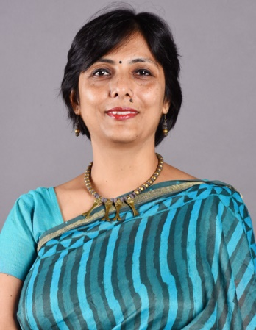
Archana Kumari Principal Lead JETREG South Asia Regional Hub  Report Presenter | Ms. Archana Kumari, an alumnus of Indian Institute of Mass Communication (IIMC) and Jawaharlal Nehru University (JNU), New Delhi; is working as Assistant Professor in the Department of Mass Communication and New Media at Central University of Jammu. She has taught at IIMC, New Delhi, Central University of Kashmir and Central University of Bihar in her academic experience of last 10 years. Beyond academics she has been active in journalism too and worked as media professional in Hindustan Times (Patna), All India Radio (Delhi), Sahara TV. She is a Fact Checking Trainer and has actively conducted over 20 fact checking workshops in all over India particularly in Jammu & Kashmir, Bihar, Punjab, Rajasthan, U.P. and Delhi.  E mail: archanaiimc@gmail.com | 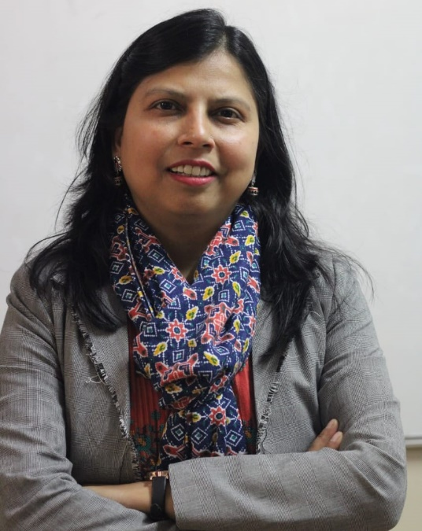
Dr Anshu Arora North India co-Lead  SARRH  JETREG | Dr. Anshu Arora is a seasoned media academician, researcher, trainer and social activist with an experience of over 24 years. She is presently working at Amity University, Uttar Pradesh. She has a doctorate from Panjab University, Chandigarh. She has won a Womenovator award in education category in the year 2021.  E mail: anshupositive28@gmail.com | 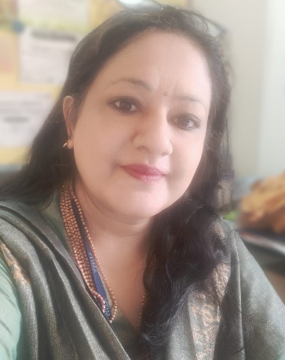
Ms Tanushree North India Lead  SARRH  JETREG | Ms. Tanushree is an Assistant Professor at Indraprastha College for Women, University of Delhi, India since 2013. A Jawarharlal Nehru University (JNU) and Indian Institute of Mass Communication fellow, her core interest lies in Advertising, Public Relations, Integrated Marketing Communication and Communication Research.  E mail: send2tanu@gmail.com | 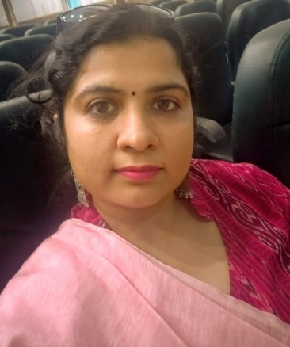
Dr. Shilpa Kalyan  South India Lead  SARRH  JETREG | Dr. Shilpa Kalyan is Associate Professor and Head of the Department - Humanities at Presidency College, Bengaluru. In her journey of over 16 years in Media Education she has been instrumental in securing top rankings and recognitions for the Media Studies Department at Presidency College. She has also worked on a UGC-sponsored minor project. She is a certified Media Literacy trainer. She is recognized by the Academic Council of uLektz as one of India's Top 50 Women Leaders in the Education Industry - 2020.  E mail: shilpa.kalyan@gmail.com | 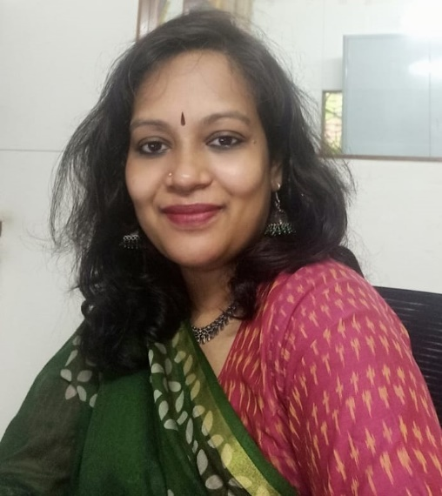
Dr. Mou Mukherjee Das East India Lead  SARRH  JETREG | Dr. Mou Mukherjee Das is presently teaching in the Department of Media Science, in Future Media School under Maulana Abdul Kalam Azad University of Technology (MAKAUT), Kolkata, West Bengal, and engaged in media literacy workshops, as a FactShala trainer. She has also done News/Media Literacy Workshop by Masato Kajimoto of ANNIE (Asian Network of News & Information Educators). She is also in the editorial board of the Media Education Lab of Renee Hobbs under the University of Rhodes, UK.  E mail: mou.mukherjeedas@gmail.com | 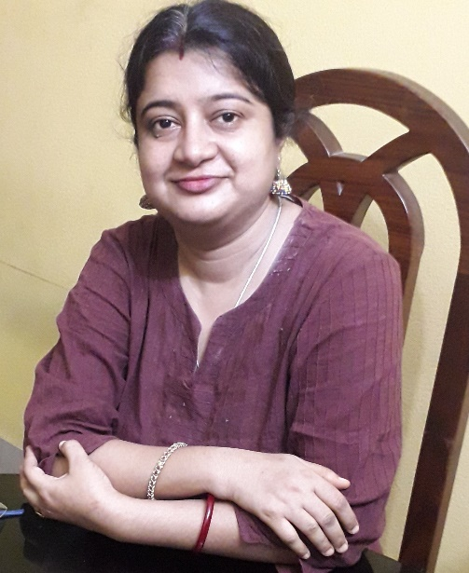
Dr. Santosh Kumar Biswal West India Lead  SARRH  JETREG | Dr. Santosh Kumar Biswal is working as Assistant Professor with Symbiosis Institute of Media and Communication (SIMC), Symbiosis International (Deemed University), Pune, India. He teaches development communication and writing for the media.  E mail - santoshkumar.biswal@gmail.com | 