Safe Space for Journalists and Journalism Educators to talk about Trauma Informed Literacy

Regional Research Hub North America Panel

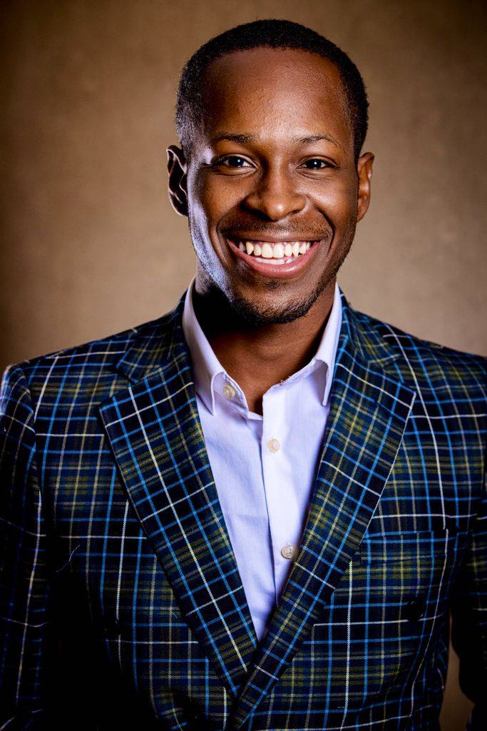

Micah Wilson is a multi-skilled journalist/reporter with 5NEWS, "covering news where you live" in Western Arkansas. He has a passion for telling stories to amplify voices, inform, and connect with the community. Micah graduated from the University of Central Oklahoma in Fall of 2020. While there he was a part of several student organizations and a member of the university’s student-run TV station, UCentral News. There, he worked as an anchor, reporter, and weather anchor. Micah has won multiple state and national awards for covering events such as protests/riots, presidential and local elections and was the founder of the Association of Black Journalists on the UCO campus.

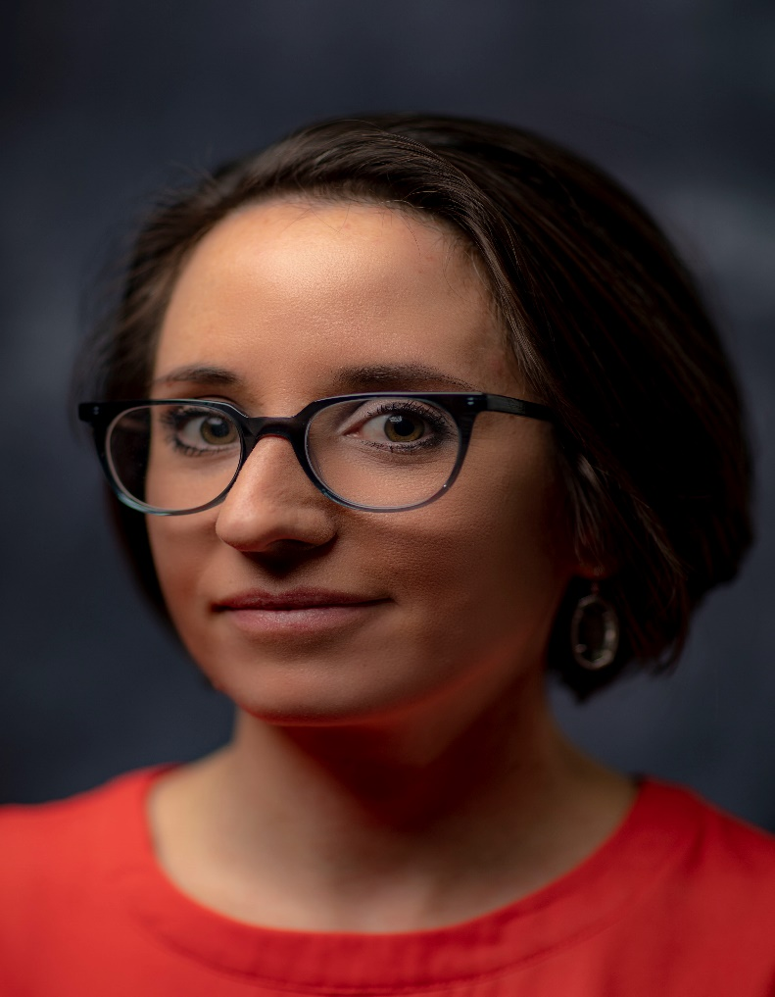

Tamara Cherry is a trauma researcher, victim advocate and communications consultant who spent the bulk of her career as an award-winning journalist in some of Canada’s largest newsrooms. She left her post as CTV News Toronto’s crime specialist in 2019 to launch Pickup Communications, a public relations firm that specializes in supporting victims and survivors of traumatic events, as well as journalists who cover trauma. Tamara is also the author of All the Bumpy Pebbles, a novel about domestic sex trafficking. She is now working on her second book, titled Unspeakable: Victims, Survivors & the Media. Part journalism, part memoir, Unspeakable is based on Tamara’s research project examining the impact of the media on trauma survivors, and the impact of trauma on journalists. Tamara is a regular voice on Newstalk 1010 radio in Toronto. She lives in Regina, Saskatchewan with her partner and their three kids.

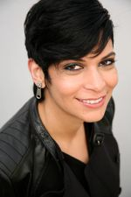

Naseem Miller is a senior health editor at The Journalist’s Resource. Previously, she was a health reporter in newspapers and medical trade publications, covering a wide range of topics from correctional health care to clinical trials. She covered the Pulse Nightclub mass shooting while at the Orlando Sentinel and later helped start the Journalists Covering Trauma Facebook group to provide support to reporters who cover tragic events. She has an undergraduate degree in molecular and microbiology and a master’s degree in journalism and public policy.

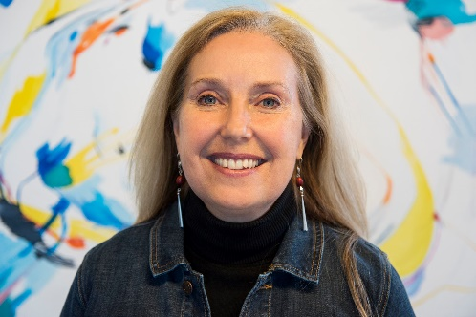

Desiree Hill, Ph.D., is a researcher, professor, former broadcast executive, and documentary filmmaker at the University of Central Oklahoma.
Her research focus on trauma incorporates broadcast news, management and leadership, and higher education/trauma training for students. She has published on the subject of trauma/journalism in the Journalism & Mass Communication Educator and the Radio-Television Digital News Association. She has presented her research internationally, including Athens (International Conference on Communication and Mass Media), Paris (World Journalism Education Congress), Sweden (International Crisis Communication Conference), and Toronto (Association for Education in Journalism & Mass Communication). Desiree’s broadcast experience includes Executive Producer for KOCO and KWTV and Vice-President of News for Pappas Telecasting. She continues to work with newsrooms across the country, including KOCO following the 2013 tornado. In 2020 she was invited by the National Weather Association to be a keynote speaker, where she focused on trauma/meteorology.

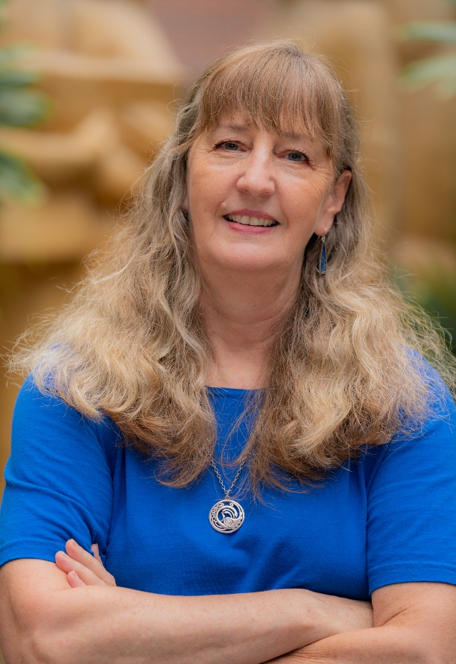
Kim Walsh-Childers is a former newspaper health reporter who has taught at the University of Florida since 1990. She received her undergraduate degree from the University of Missouri-Columbia and her master’s and Ph.D. from the University of North Carolina-Chapel Hill. At UF, Walsh-Childers has taught undergraduate courses in newswriting, magazine and feature-writing, journalism ethics and solutions journalism. Most recently, she has co-created and co-taught a course aimed at helping non-journalism majors understand how to find trustworthy news sources and how to evaluate the impact of quality journalism on state and local government. At the graduate level, she has taught journalism and media ethics courses, mass communication theory and a long-running graduate seminar in mass media effects on health.
Dr. Walsh-Childers’ research focuses on the role of media, particularly news coverage, in influencing individual health beliefs and behaviors and the development of health policy. She is the author of Mass Media and Health: Examining Media Impact on Individuals and the Health Environment (Routledge, 2017), and is currently co-editing a handbook of science and health journalism (with Dr. Merryn McKinnon of Australian National University). Her work has been published in Health Communication, Journalism and Mass Communication Quarterly, Newspaper Research Journal, Science Communication, Journal of Mass Media Ethics, American Journal of Men’s Health, and Australian Review of Journalism, among others.

