PRESS RELEASE: West End and ITV actors to star in original play based on newsroom trauma in Sheffield

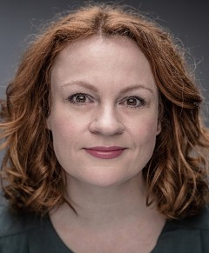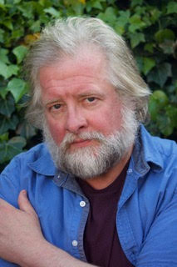

Unbreakable, a one-act play centred around the everyday trauma journalists experience in the newsroom, will be performed at the University of Sheffield on June 15 with free access to the public.

Devised by award-winning Journalism Studies lecturer, crime author and former journalist Lisa Bradley and television actress Lucy Mizen (top left), the play is funded by the University of Sheffield and seeks to explore and raise awareness of the impact of trauma on journalists.

The play features a cast of rising stars and west-end veterans from around Yorkshire, including Lucy Mizen (Coronation Street, the Full Monty, Emmerdale), Ian Jervis (top right; Phantom of the Opera, Oliver!, Made in Dagenham) and Leeds-born theatre actress Ellen Carnazza (centre).

To write Unbreakable, the two co-authors drew on Lisa’s own personal experiences as a regional and national reporter for titles like the Sun and the Wakefield Express, as well as interviews with a wide range for journalists from trainee reporters to war correspondents.

Lucy said: “Lisa and I have been friends for more than 40 years, but this is the first time we’ve ever had the chance to work together.

“Having witnessed first hand the impact crime reporting had on Lisa in the early years of her career, and understanding the power of responsible and ethical journalism in the world, this is an important message to raise awareness to a wider audience.”

The performance comes as part of a wider programme of events hosted by the Journalism Education Trauma Research Group, entitled ‘Living to tell the tale’ - Building Community Resilience in Journalism’.

Lada Price is a Senior Lecturer in Journalism Studies at the University of Sheffield and co-leader of the Journalism Education Trauma Research Group (JETREG). She said:

“The issue of trauma and poor mental health in journalism still carries a lot of stigma in newsrooms - Journalists are reluctant to talk about their own experiences but, as educators and scholars, we have a duty of care to our students and young journalists to prepare them to cope with future challenges in their daily practice.

“The idea behind this play is to engage a diverse community of scholars, journalists, students and members of the public with the issue and raise awareness in an innovative and engaging way that demonstrates the reality in many newsrooms.”

Unbreakable will take place at the University of Sheffield Drama Studio on Thursday 15 June, 7.15pm. The show has a running time of approximately 1 hour 15 minutes. tickets are free and can be secured via eventbrite.

Notes to editors:

Lucy Mizen trained at Yorkshire Academy of Film and Television Acting and is a professional singer, voice over artist and actress. She recently starred as Patricia Hall in Prime Video's The Confession, in Coronation Street, The Full Monty and Emmerdale. She has extensive stage experience as well as theatre-in-education.

Lisa Bradley is an award winning former crime reporter, mass market thriller novelist, award winning lecturer and Deputy Head of the Department for Journalism Studies at University of Sheffield. She is the co-editor of forthcoming book Journalism as the fourth emergency service: Building trauma and resilience training into Journalism education.

Ellen Carnazza is a Leeds born theatre, screen and voice actor. Specialising in actor-musicianship children's theatre and immersive theatre . Ellen has trained with the National Youth Theatre Company and Red Ladder theatre company and is also a writer, director, facilitator and co-founder of community-focussed immersive theatre company, Flights of Fantasy.

Ian Jervis originally hails from Derby but now lives in Harrogate North Yorkshire. He trained at the Birmingham Conservatoire and the Royal College of Music in London. Ian has a decades long career in theatre with credits including The West end productions of The Phantom of The Opera, Mr Bumble in Oliver and Sid in Made in Dagenham. Ian is also a wonderful opera singer and has played Falstaff and Colline in the modern television adaptations of Verdi’s Falstaff and Puccini’s Boheme.

The Department of Journalism Studies at the University of Sheffield is rated in the top 5 for media and journalism by all three of the UK's independent university league tables. It has an excellent reputation for teaching and research across all areas of journalism and political communication, and boasts accreditation from the NCTJ, BJTC and PPA. It is the home of several research centres, including the Centre for Freedom of the Media (CFOM) and lists prolific journalists Dan Walker and Martha Kelner among its notable alumni.

